

American International University- Bangladesh

**Department of Computer Science**

Term Project Proposal, FALL 18-19

|  |  |  |  |
| --- | --- | --- | --- |
| Course Title | WEB TECHNOLOGIES | Section | H |

**Group Members:**

|  |  |  |
| --- | --- | --- |
| Student ID | Name | Signature |
| 20-44115-2 | A.S.M. SAYEM |  |
| 20-43914-2 | ANIK KUMAR DAS |  |
|  |  |  |
|  |  |  |

**E-HEALTH**

**Introduction:**

**Background Study:**

**Requirement Analysis:**

1. **User Category:**

in There are 4 types of users here. Such as:

1. Admin.
2. Patient.
3. Doctor.
4. Manager.
5. **Feature List:**

Here, the “**Admin**” has have following features:

* Admin registration page.
* Admin login page.
* Admin can access Patient and Doctors Data.
* Admin can view patient and manager data

Here, One “**Patient**” has have following features:

* Patient registration form.
* Patient login form.
* Patient can see doctor’s list.
* Patient can see Appointment fees and other test fees.
* Patient can apply for doctor’s appointment.
* Patient can logout.

Here, one “**Doctor**” has have following features:

* Doctor registration page.
* Doctor login page.
* Doctor can see patient list.
* Doctor can logout and destroy session.

Here, the “**Manager**” has have following features:

* Manager registration page.
* Manager login page.
* Manager can see of his/her profile page.
* Manager can logout.

**ER Diagram:**

**Tools Used:**

To develop this project, we have used the following:

* Visual studio code.
* XAMPP Control Panel.
* Chrome.
* Mozila Firefox.
* MS Word.
* Draw.io.
* Google

**System Images against the Specification:**

**1.Admin**

…………………………………………………………………………………………

**2.Patient**

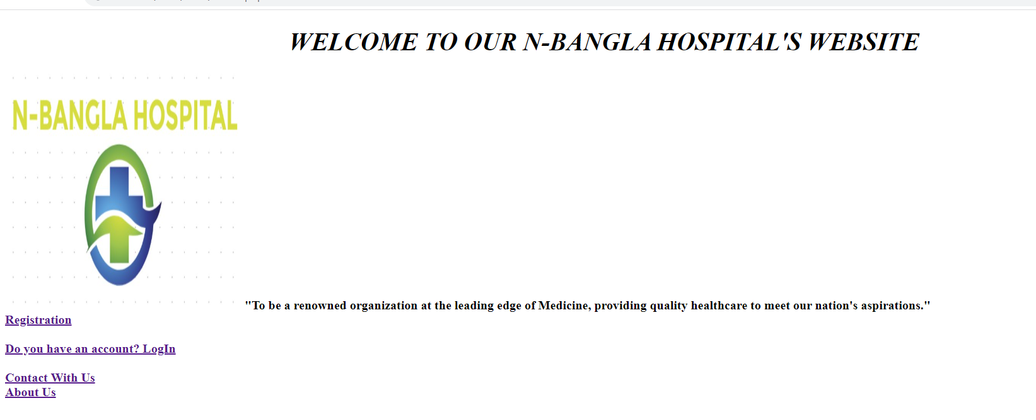

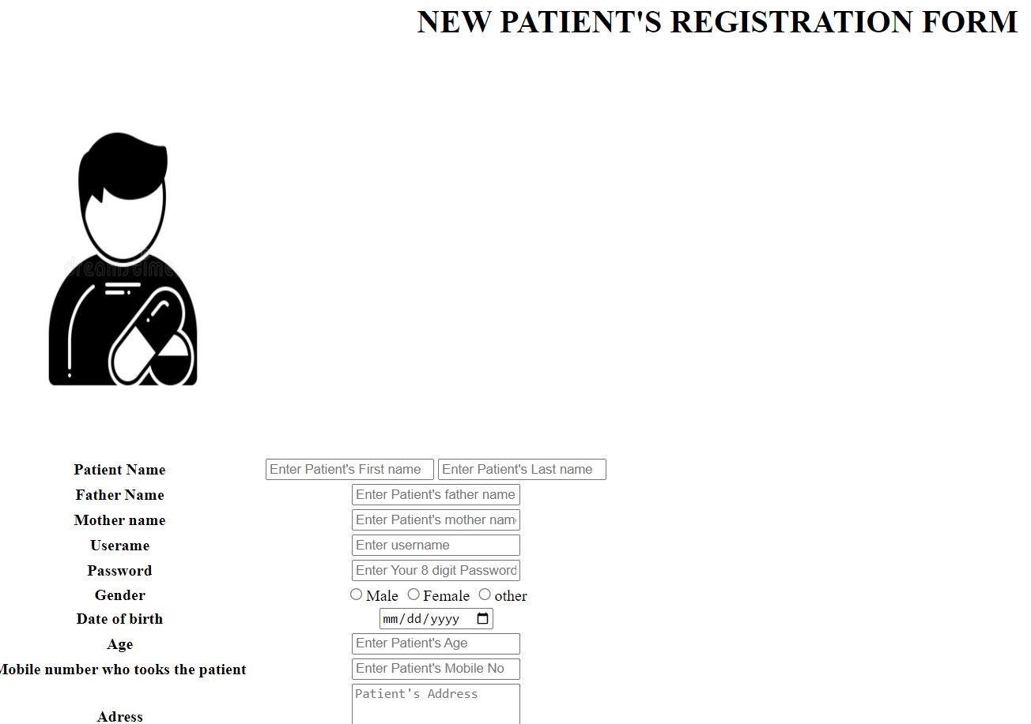

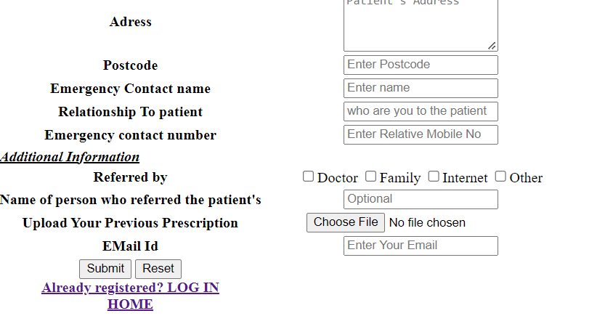

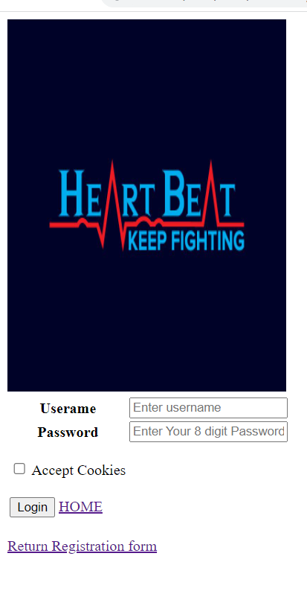

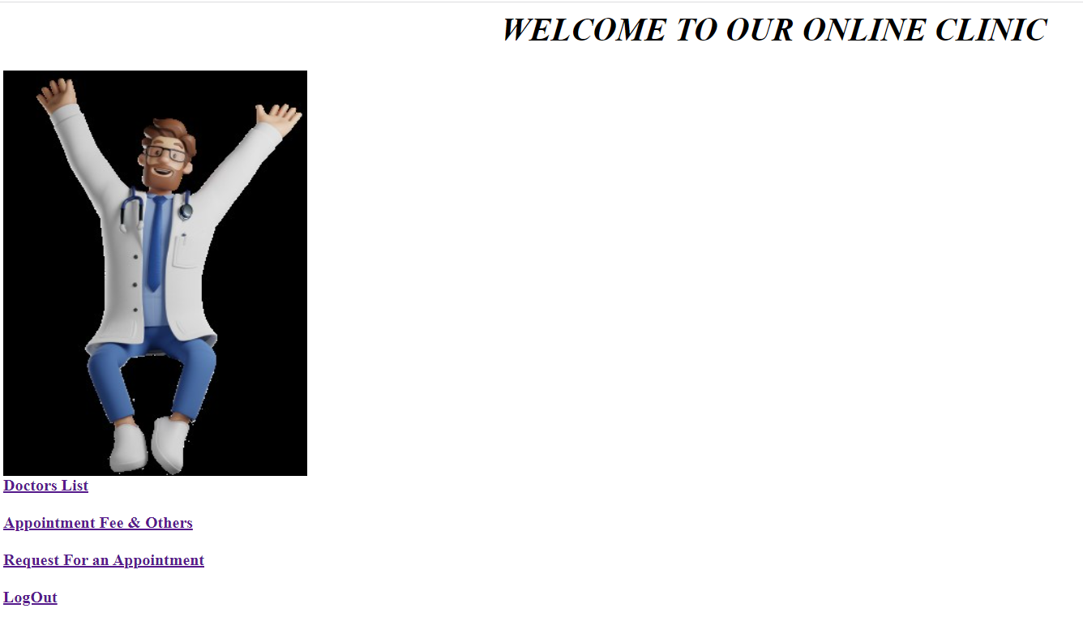

**3.Doctor**

……………

**4.Manager**

……………………….

**Influence of this Project:**

E-health system are designed to improve health surveillance, make easy the process of taking appointment of doctors and found the doctors. Through this system a patient can do everything in time.

Difficulties in meeting health targets, such as the Millennium Development Goals, and rising consumer demand have compelled health planners to look for novel ways to improve the outcomes of health-care and public-health initiatives while keeping service costs under control. As people are being hassled while taking an appointment, we are trying to develop this system.

**Limitations and Possible Future Improvements:**

As, we are developing this system with a few data, we are doing this easily. But if we want to do this globally in our country, it will take too long time and it will be tough to took all the hospital under one system